TJ DCR Project -Audio Amplifier

- Lay out the board... 12 pads total  - Use half inch pads for the base and quarter inch pads everywhere else.  - Three transistor rows, three pads each.  - One row of two pads for the potentiometer between Q3 and Q4.  - One pad for the output. | 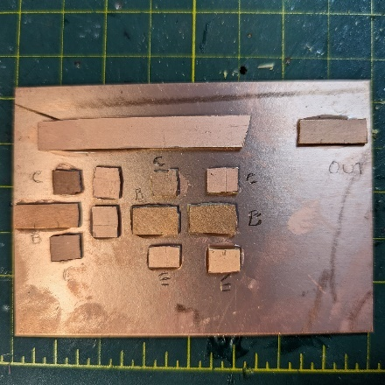
- Solder in all resistors for the first stage  - Check the values  - Conserve space on the pads – there are many components to solder in | 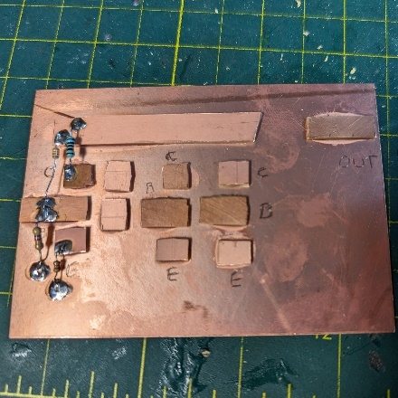
- Capacitors next –  - Electrolytics are polarized – look for the – or >>>  - Check the schematic for correct orientation | 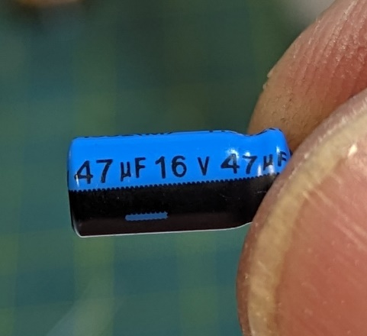
- Solder in the caps for the DC rail and first stage | 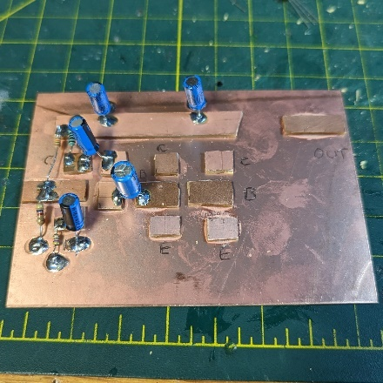
- Transistor is next  - Carefully check the leads  - 2N3904 – looking at the flat face from left to right  - E, B, C | 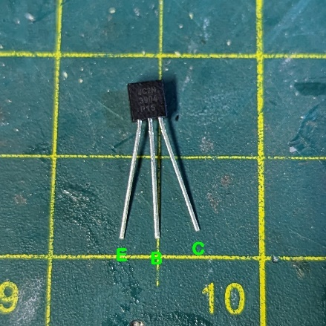
- Measure and record the voltage on the Collector, Base and Emitter | 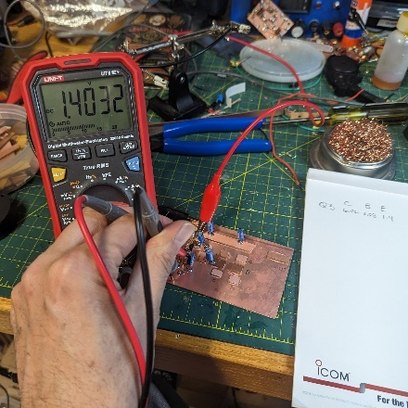
- Prepare the volume pot.  - Get 6” each of red, black and green wire  - Braid the wire – this acts a natural shield keeping unwanted signals out | 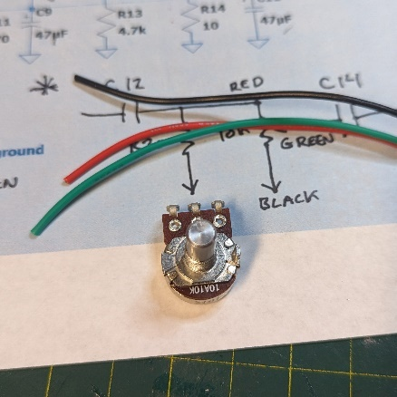
- Potentiometer wiring  - Red to the signal side  - Green to the middle (wiper)  - Black to the ground side | 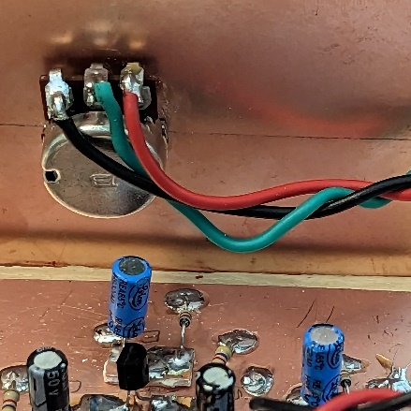
- Solder in the pot leads  - Connect a speaker to the output pad and touch the input with a screwdriver or piece of wire – you should hear a buzz  - Adjust the volume to see if it goes up and down | 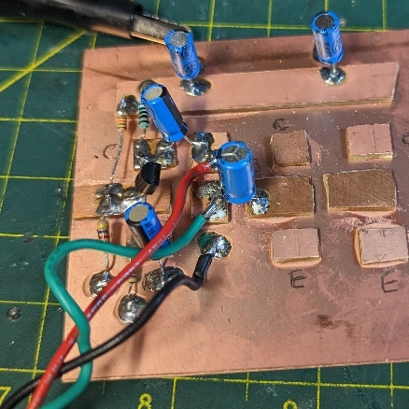
- For the second stage
  - Solder the resistors
  - Solder the caps
  - Solder the transistor, Q4
  - Check and record the voltages on C, B,E
  - Repeat the buzz test
- Fort the third stage  - Solder the resistors, no collector resistor on Q5  - Solder the caps  - Solder the transistor, Q5  - Transformer –  - Bend up the middle leads – we won’t use those  - Look for the “P” for primary winding – that side goes to Q5 | 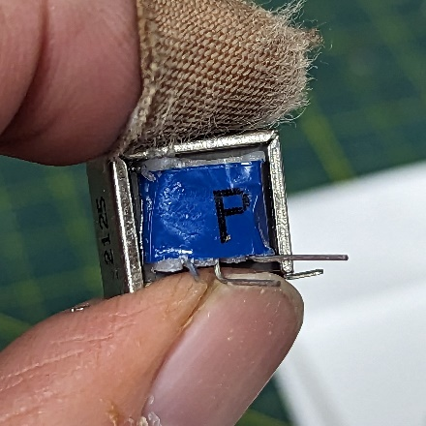
- On the “P” side – top lead to the DC rail, bottom lead to the collector of Q5  - On the output side, top lead to the output pad, bottom lead to ground  - Check and record voltage on Q5 C,B,E  - Hookup speaker and test | 